**EXPERIMENT :21** Demonstrate Infrastructure as a Service (IaaS) by creating a resources group using a Public Cloud Service Provider (Azure), configure with minimum CPU, RAM, and Storage.

**AIM:**

**1.**

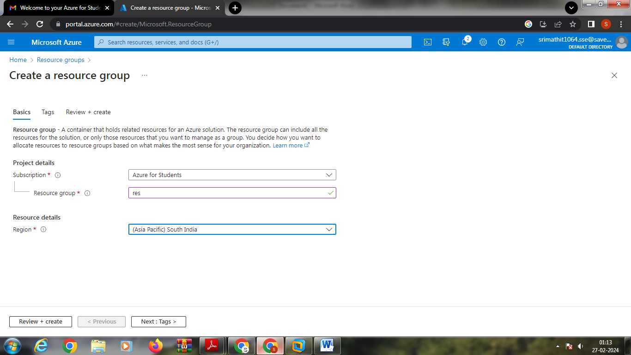

**2.**

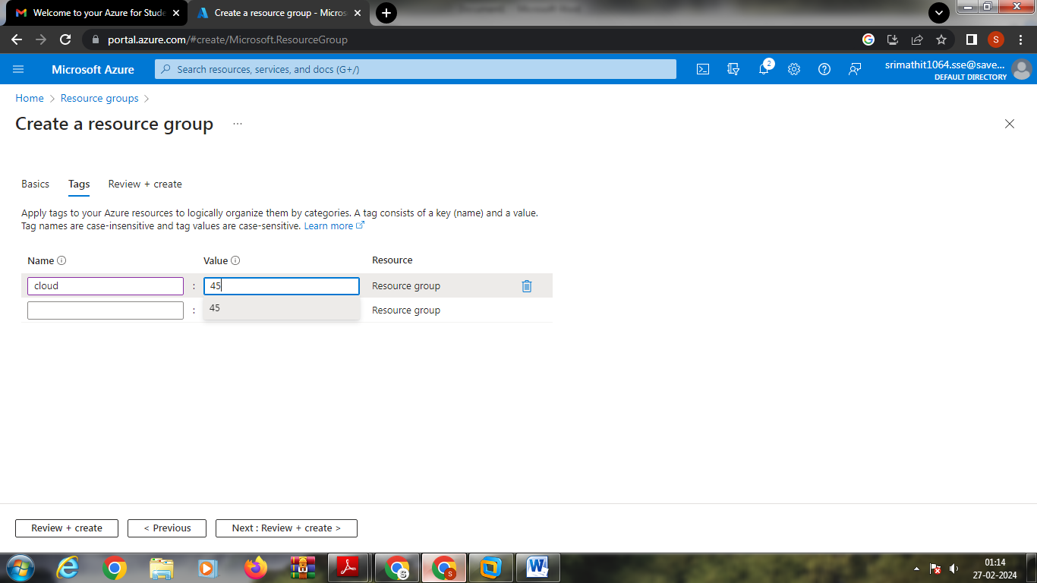

**3.**

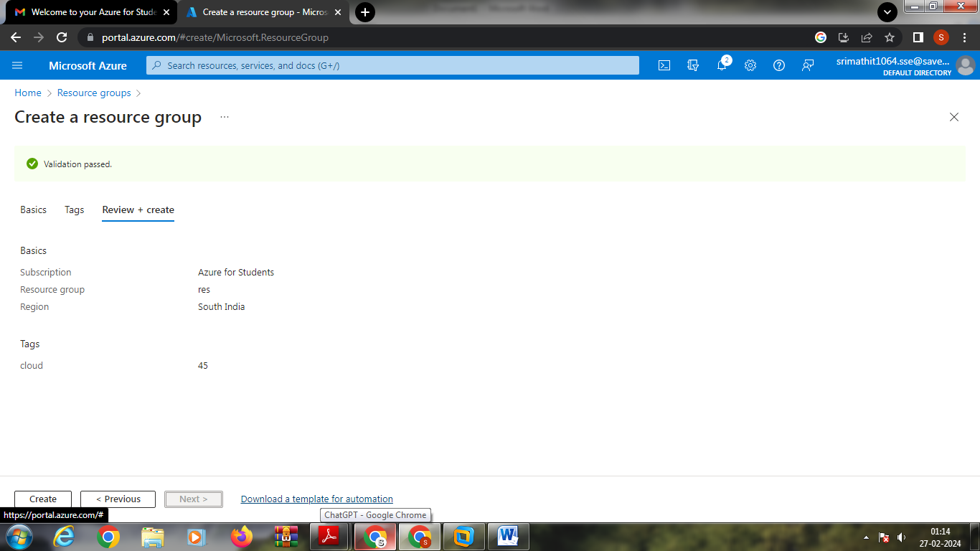

**4.**

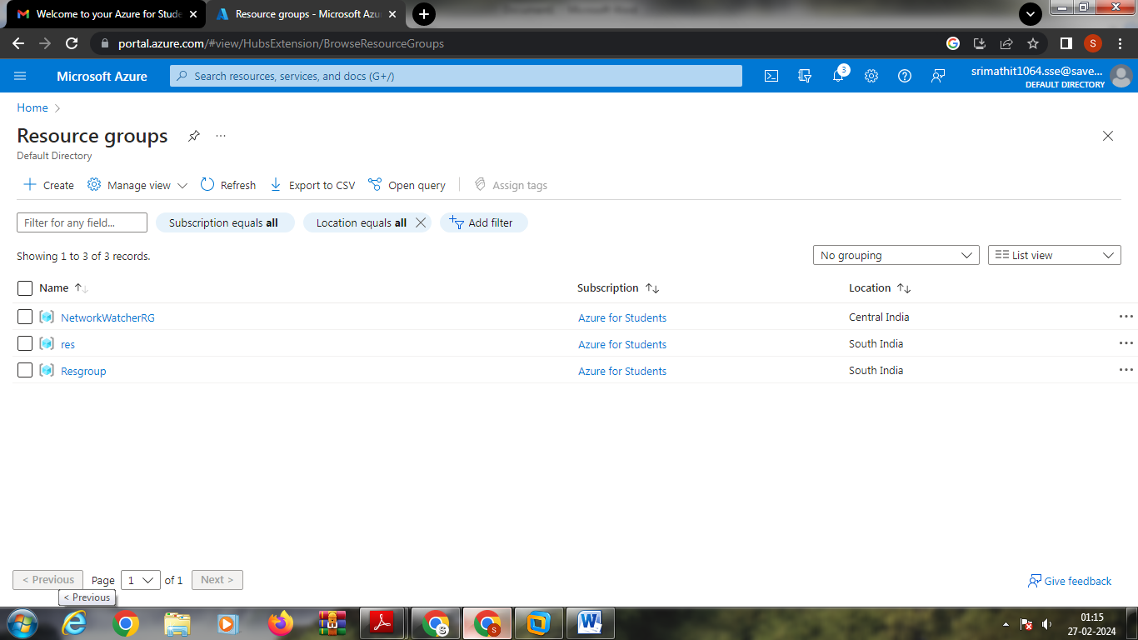

**5.**

**6.**

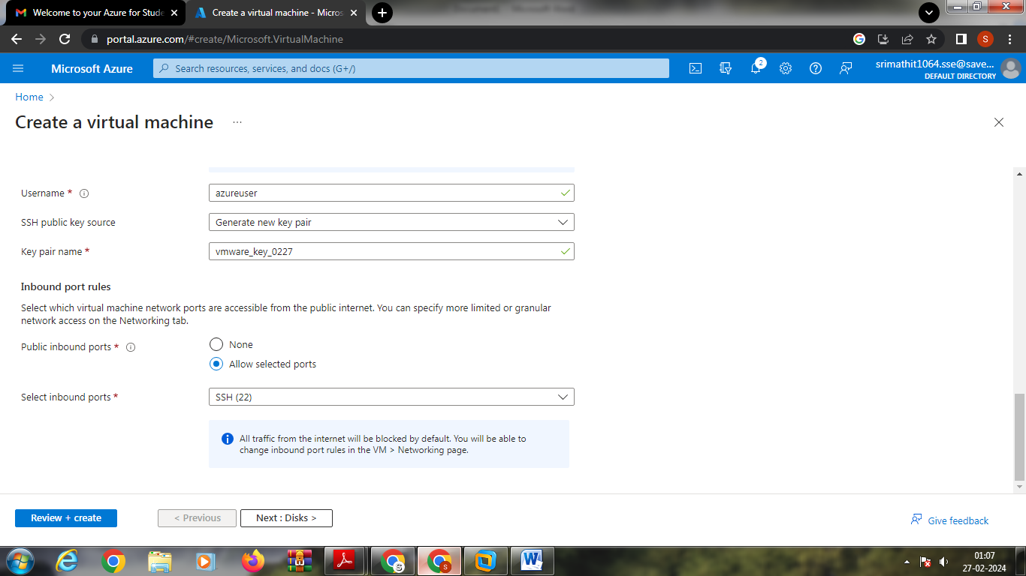

**7.**

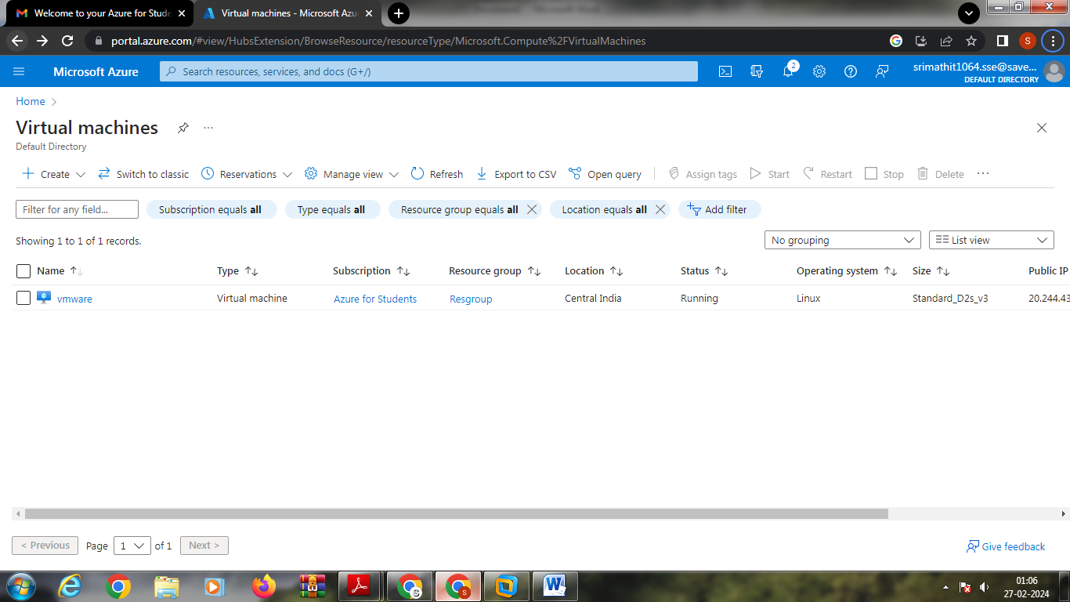

**8.**

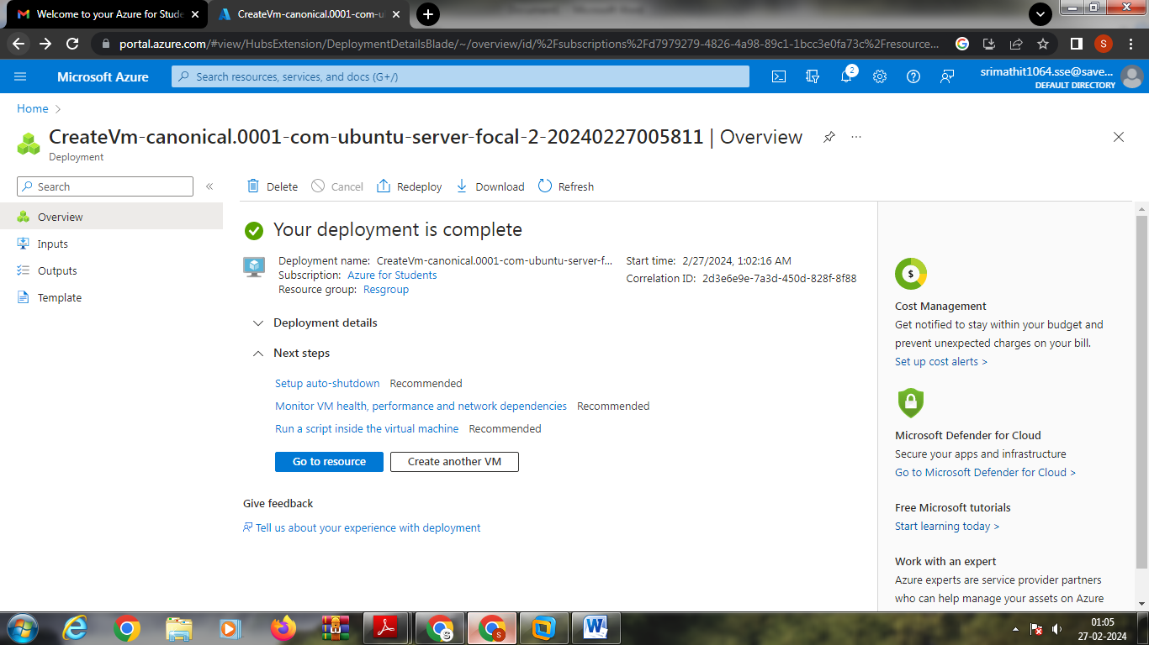

**9.**

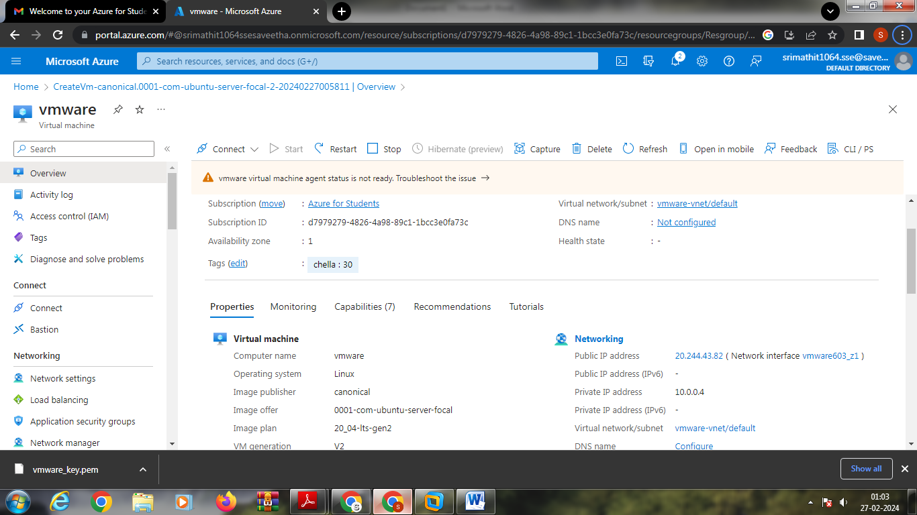

10. 